Project Manual: Job Portal Setup
Date: February 25, 2026
Framework: Node.js / Next.js (Recommended for Vercel)
Database: Supabase
Deployment: Vercel & GitHub

1. Project Initialization
First, we will create the local foundation for your Job Portal.
- Open your terminal or command prompt.
- Navigate to the folder where you keep your projects.
- Run the following commands to create the directory and initialize the project:
  - mkdir job-portal
  - cd job-portal
  - npm init -y (or npx create-next-app@latest . if using Next.js)
- Open the folder in your code editor (e.g., code . for VS Code).

2. GitHub & Vercel Integration
This step ensures your code is backed up and automatically deployed whenever you make changes.
Step 2.1: GitHub Repository
- Go to github.com and create a new repository named Job-Portal.
- In your local terminal, run:
  - git init
  - git add .
  - git commit -m "initial commit"
  - git branch -M main
  - git remote add origin [YOUR_GITHUB_REPO_URL]
  - git push -u origin main
Step 2.2: Vercel Connection
- Log in to Vercel.com.
- Click "Add New" > "Project".
- Import your Job-Portal repository from GitHub.
- Click Deploy. Vercel will now monitor your GitHub; every time you git push, the site updates automatically.

- Directory Structure

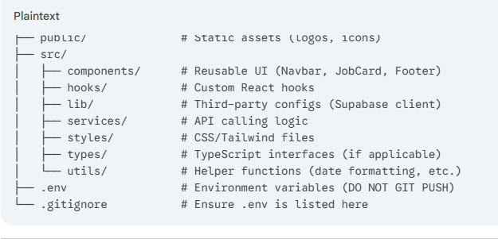
A clean Job Portal requires organized folders for job listings, user profiles, and resumes. Create the following folder structure in your root directory:
Plaintext
job-portal/
├── public/ # Static assets (logos, icons)
├── src/
│ ├── components/ # Reusable UI (Navbar, JobCard, Footer)
│ ├── hooks/ # Custom React hooks
│ ├── lib/ # Third-party configs (Supabase client)
│ ├── services/ # API calling logic
│ ├── styles/ # CSS/Tailwind files
│ ├── types/ # TypeScript interfaces (if applicable)
│ └── utils/ # Helper functions (date formatting, etc.)
├── .env # Environment variables (DO NOT GIT PUSH)
└── .gitignore # Ensure .env is listed here

4. Supabase Database Connection
Supabase will handle your user authentication and the storage of job postings.
Step 4.1: Create Supabase Project
- Go to Supabase.com and create a new project named Job Portal.
- Wait for the database to provision.
- Go to Project Settings > API.
- Copy the Project URL and the anon public API key.
Step 4.2: Local Configuration
- In your local project root, create a file named .env.
- Paste your credentials:
Code snippet
NEXT_PUBLIC_SUPABASE_URL=your_project_url_here
NEXT_PUBLIC_SUPABASE_ANON_KEY=your_anon_key_here
- Install the Supabase library:
  - npm install @supabase/supabase-js
Step 4.3: Initialize the Client
Create a file at /src/lib/supabaseClient.js and add the following:
JavaScript
import { createClient } from '@supabase/supabase-js';

const supabaseUrl = process.env.NEXT_PUBLIC_SUPABASE_URL;
const supabaseAnonKey = process.env.NEXT_PUBLIC_SUPABASE_ANON_KEY;

export const supabase = createClient(supabaseUrl, supabaseAnonKey);

5. Syncing Environment Variables to Vercel
For the live site to work, Vercel needs your Supabase keys too:
- Go to your Vercel Dashboard > Job Portal Project.
- Settings > Environment Variables.
- Add NEXT_PUBLIC_SUPABASE_URL and NEXT_PUBLIC_SUPABASE_ANON_KEY with their respective values.

Manual Complete. Would you like me to provide the SQL schema to create the jobs and profiles tables in your Supabase dashboard next?
If git hub password not sent
Plan B: The "Fresh Start" Strategy
Since you have the code on your F: drive, we can just move it to a new GitHub account (or a different email) so you aren't stuck waiting for an email that might never come.
Here is exactly what to do:
- Create a New GitHub Account: Go to GitHub.com in Edge and sign up with a different email address (one you can access right now). Save that password in Chrome immediately!
- Create a New Repository:
  - Click the "+" icon in the top right > New repository.
  - Name it job-portal.
  - Click Create repository.
  - Copy the new URL (it will look like https://github.com/NEW_USERNAME/job-portal.git).
- Update your Git Bash to the New Account: Go back to your terminal and run this command with your new URL:
Bash
git remote set-url origin https://github.com/NEW_USERNAME/job-portal.git
- Push the Code:
Bash
git push -u origin main

💡 Why this works:
When you run the push command with the new URL, Windows will pop up a window asking you to "Sign in with your browser." Since you'll already be logged into your new account in Edge, it will just ask you to click "Authorize," and BOOM—your code will be on GitHub instantly!
Does creating a new account sound like a good plan to get you moving again, or would you like to try one more "Deep Search" in your current email for that reset link?
Your "Day 2" Checklist:
- Check Vercel: Make sure the deployment is green.
- Verify localhost: Run npm run dev and make sure your Sign-Up page looks good.
- Build the Login: We will create the login/page.js to match your Sign-Up design.
- Test the Flow: Sign up a fake user, then try to log in with those same details.

